**sports in bharat**

#### 1D.Geetha, 2S.Sandeep Babu, 3D.Manogna, 4G.Rishitha, 5P.Usha Rani

1Mtech,Ph.d,Assistant Proffessor,Dept of CSE(AL&ML), Vignans Institute of Management and Technology for Women, HYD, India,

2Assistant Professor in Dept. of CSE (AL&ML) VMTW Hyderabad.

(3,4,5) BTech 2th year Student, CSE (AI&ML), Vignan's Institute of Management and Technology for Women, Hyderabad, India.

1[drshanthicse@gmail.com](mailto:drshanthicse@gmail.com), 2[ashok6.gunti@gmail.com](mailto:ashok6.gunti@gmail.com), 3[biswalchaitrika@gmail.com](mailto:biswalchaitrika@gmail.com), 4[mdeekonda2005@gmail.com](mailto:mdeekonda2005@gmail.com), 5[Sirisiri2288@gmail.com](mailto:Sirisiri2288@gmail.com),

**ABSTRACT:**

We developed an interactive web application showcasing India's map, highlighting each state's official sport. Using HTML and CSS, we created a dynamic platform where users can click on a state to reveal its respective sport. This project aims to digitally showcase sports across India, promoting awareness and understanding of regional athletic traditions .While existing platforms like Bharat Maps have explored similar concepts, they have only achieved about 30% of the potential. Our project strives to take this further, covering nearly 80% of the scope, providing a more comprehensive and engaging experience for users to explore India's diverse sporting landscape.

**Keywords:** HTML, CSS, JavaScript, AI Interactive Tools, Front-end Development, Dynamic Content, Popup Integration, Map Integration, CSS Animations, HTML5.

**I. INTRODUCTION:**

The "Sports in Bharat" project is an innovative digital initiative that celebrates the rich cultural diversity of India by showcasing its traditional and popular sports across different states and union territories. Through an interactive map, users can explore and learn about various sports that are deeply rooted in the country's heritage. The platform features user-friendly interactive elements, including pop-ups that display state names and associated sports, allowing users to discover detailed content such as origin, rules, and famous athletes.

By documenting and sharing information about traditional sports, the project helps preserve India's cultural heritage and promotes regional pride by showcasing unique sports specific to each state or region. The platform serves as a valuable resource for students, researchers, and anyone interested in learning about India's diverse sporting traditions. Built using HTML, CSS, and JavaScript, the platform ensures a responsive and interactive user experience.

The project's impact extends beyond education, as it helps revive interest in indigenous sports and games, promoting their relevance in modern times. It facilitates cultural exchange and understanding among users from different regions and inspires young learners to explore and appreciate India's rich sporting heritage. With its modular design, the platform allows for future enhancements, such as adding audio clips, quizzes, and user-submitted stories, offering a meaningful and engaging experience for users.

The platform features user-friendly interactive elements, including pop-ups that display state names and associated sports. Clicking on a state or pop-up reveals detailed content, such as origin, rules, and famous athletes. Smooth transitions and attractive visuals create an engaging experience.

This project serves as a cultural mission, reviving interest in indigenous sports like Kabaddi, Kalaripayattu, Mallakhamb, and Thang-Ta. It preserves knowledge, encourages pride and curiosity in young learners, and bridges generations.

Built using HTML, CSS, and JavaScript, the platform is responsive and modular, allowing for future enhancements like audio clips, quizzes, and user-submitted stories. Sports in Bharat offers a meaningful and educational digital experience, integrating technology and tradition.

**II. RELATED WORK:**

The "Sports in Bharat" project was developed using a combination of technologies and resource.

1. HTML, CSS, and JavaScript were utilized to create an interactive and dynamic platform, allowing users to engage with the content seamlessly.

2. To gather accurate and reliable data, reputable sources such as Wikipedia and Britannica were consulted, providing a solid foundation for the project.

3. Maps of India was also referenced to ensure the precise representation of India's geographical landscape.

4. A comprehensive literature survey was conducted by referencing UGC research papers, offering valuable insights into traditional and modern sports.

5. Images were sourced from free stock websites, ensuring visually appealing content without copyright concerns.

6. link was employed to obtain coordinates for the interactive map, enabling precise mapping of sports across different regions.

7. AI interactive tools were leveraged to find relevant information, enhancing the project's accuracy and depth.

8. YouTube videos were watched to gain further insights and understand various concepts related to sports in India.

9. Various online resources were utilized to gather information about traditional and modern sports, showcasing India's rich sporting heritage.

10. Multiple sources were cross-referenced to ensure the accuracy and validity of the information used in the project.

11. The project's design prioritized responsiveness, guaranteeing a smooth user experience across various devices and screen sizes.

12. The development process involved meticulous attention to detail, ensuring that the platform was both informative and engaging.

13. By combining traditional research methods with modern technologies, the project achieved a comprehensive and immersive representation of sports in India.

14. The use of diverse resources and technologies facilitated the creation of a robust and reliable platform.

15. Overall, the "Sports in Bharat" project demonstrates the effective integration of technology, research, and cultural preservation, offering a unique and educational experience for users.

**III. PROPOSED SYSTEM:**

1. **Overview of the Proposed System:**

The system is designed to render an interactive map of India directly within the user's browser, where each state is represented as a distinct, clickable element. When a user clicks on a specific state, a JavaScript event listener tied to that element is triggered, initiating the core functionality of the application. This event listener detects which state was clicked and uses that information to perform a data lookup within a predefined JavaScript object that maps states to their officially recognized sports. Once the system retrieves the sport associated with the selected state, it dynamically updates a designated section of the webpage—such as a text box, pop-up window, or sidebar—to display the relevant information to the user in real time. This streamlined interaction provides users with immediate, localized insights through a seamless and intuitive interface.

1. **Overall System Architecture:**

The "Sports in Bharat" project is an innovative digital initiative that celebrates India's diverse sporting heritage through an interactive platform. By featuring a map that highlights traditional and popular sports across different states and union territories, the project promotes regional pride and educates users about the country's rich sporting traditions. The platform's interactive design, built using HTML, CSS, and JavaScript, provides a seamless user experience, allowing users to explore and learn about various sports in a engaging and immersive way. By documenting and sharing information about traditional sports, the project helps preserve India's cultural heritage and sparks curiosity in young learners, inspiring them to learn more about the country's sporting history and traditions.

Moreover, the project plays a significant role in reviving interest in indigenous games and promoting their relevance in modern times. By showcasing the diversity and richness of India's sporting heritage, the project contributes to the country's cultural preservation efforts and promotes a sense of national pride and identity. Overall, the "Sports in Bharat" project is a valuable resource for anyone interested in learning about India's sporting traditions, and its interactive platform makes it an engaging and enjoyable experience for users of all ages.

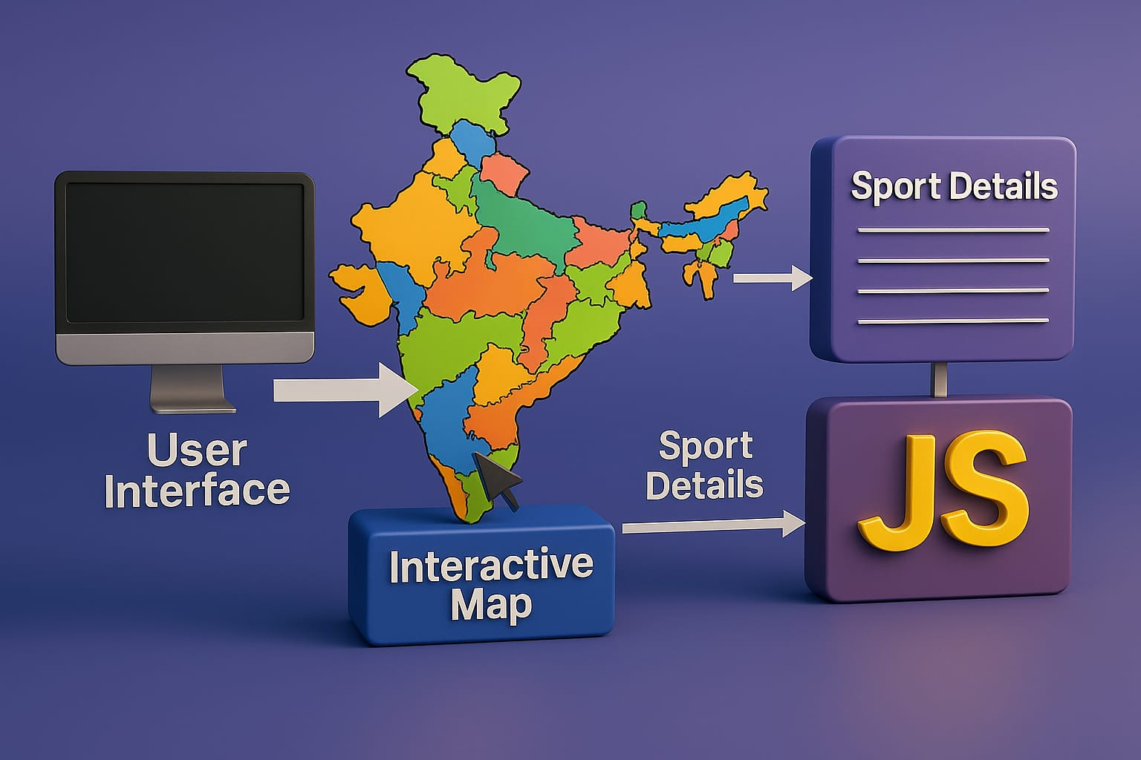

**Figure. 1.** System Architecture of Sports In Bharat

1. **User Interface:**

The user interface is represented by a computer monitor, indicating that the system is designed to be accessed through a digital platform. The user interacts with the system through this interface, which is likely to be a web application or a desktop application.

**D. Interactive Map:**

The interactive map is a crucial component, displaying a colorful representation of India's states. This map is likely to be clickable, allowing users to select specific regions and access related information. The map is likely to be created using a mapping library or framework, such as Google Maps or Leaflet.

**E. Sport Details:**

When a user interacts with the map, the system retrieves and displays "Sport Details" related to the selected region. This information is likely to be stored in a database or data structure such as a JSON file or a relational database. The sport details may include information such as the name of the sport, its history, rules, and notable athletes from the region.

.

**F. JavaScript (JS):**

The "JS" component is likely responsible for handling the interactive functionality of the map and retrieving the relevant sport details. JavaScript is a popular programming language used for client-side scripting and is well-suited for creating interactive web applications. The JavaScript code is likely to be used to handle events such as mouse clicks on the map, retrieve data from the database or data structure, and update the user interface with the relevant sport details.

**G. Workflow:**

The workflow of the system involves the user interacting with the map through the user interface, the interactive map responding to user input and triggering the retrieval of sport details, the system using JavaScript to fetch the relevant sport details, and the sport details being displayed to the user through the user interface.

**H. Key Takeaways:**

The system architecture depicted in the image is designed to provide an engaging and informative experience for users. By leveraging an interactive map and JavaScript, the system enables users to explore and learn about various sports associated with different regions of India.

**IV. IMPLEMENTATION DETAILS:**

**A. Project Overview:**

The "Sports in Bharat" project is an interactive web application that showcases the diverse sporting heritage of India. The project features an interactive map of India, highlighting different states and their associated sports.

**B. Front-end Development:**

The project uses HTML, CSS, and JavaScript to create a structured, interactive, and visually appealing web page.HTML: Used to create the basic structure of the web page, including the map and other interact

CSS: Utilized to design and layout the web page, making it visually appealing and user-friendly.

JavaScript: Employed to add interactivity to the web page, enabling features like hover effects and clickable elements.

1. **Interactive Map:**

The interactive map is a crucial component of the project, displaying a colorful representation of India's states.

Map Library: A JavaScript library (e.g., Google Maps, Leaflet) is used to create the interactive map.

State Boundaries: The map is designed to display state boundaries and associated sports.

1. **Sport Details:**

When a user interacts with the map, the system retrieves and displays "Sport Details" related to the selected region.

Data Storage: Information about the sports is stored in a database or data structure (e.g., JSON file).

Data Retrieval: JavaScript is used to fetch the relevant sport details when a user interacts with the map.

1. **Hover Effects:**

The map is designed to display a popup with the state name and sport when hovered over.

1. **Clickable Elements:**

Clicking on a state or popup reveals detailed information about the sport, including its origin, rules, and famous athletes**.**

**G. Responsive Design:**

The website is designed to be responsive, ensuring a smooth user experience across various devices and screen sizes.

**I. Data Sources:**

Information about the sports was gathered from reputable sources, including Wikipedia, Britannica, and Mapsofindia**.**

**J. Benefits and Impact**

The "Sports in Bharat" project promotes India's rich sporting heritage, showcasing a variety of traditional and modern sports from different regions. The project serves as an educational tool, encouraging users to learn about and appreciate the diverse sporting culture of India.

**V. EXPERIMENTAL RESULTS AND ANALYSIS:**

**A. Experimental Setup:**

The experimental setup consists of a system architecture that enables users to interact with a map of India and retrieve information about various sports associated with different regions. The system comprises several key components, including a user interface, an interactive map, and a JavaScript module. The user interface is represented by a computer monitor, indicating that the system is designed to be accessed through a digital platform. The interactive map is a crucial component, displaying a colorful representation of India's states, and is likely to be clickable, allowing users to select specific regions and access related information.

The system's functionality is centered around the interactive map, which retrieves and displays sport details related to the selected region. The JavaScript module handles the interactive functionality of the map and retrieves the relevant sport details. The system requires a digital platform, such as a web application or a desktop application, to function. The system has potential applications in education, sports development, tourism, and research, and can be used as an educational tool, to promote sports development and awareness, promote tourism, and as a research tool to study different sports and their associated regions in India.

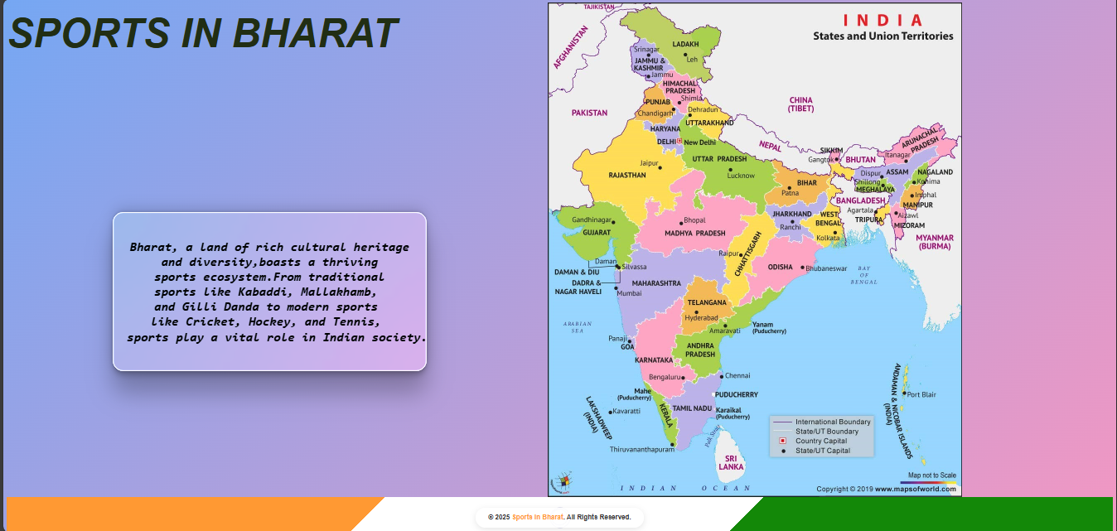

**Fig.2:** Interactive India Map

The figure 2 Show a the interactive India map which on moving a cursor on to and state you can see a popup which contains the sport image and sport name.

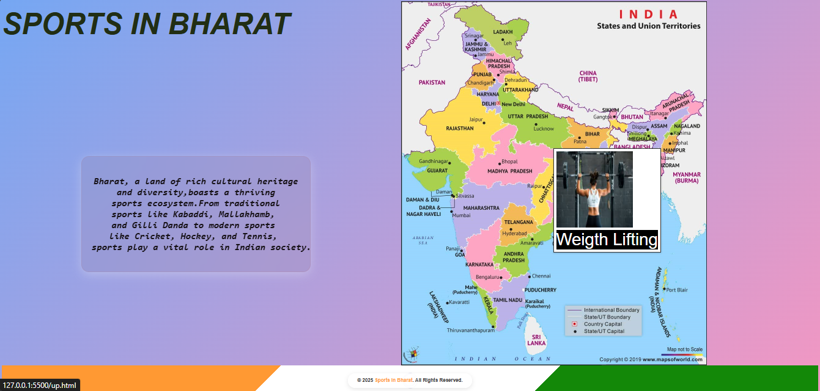

**Fig. 3:** Popup of a Particular state

In the above image we can see that when we move the cursor on to the particular state you see a popup which contains a state sport image and its name

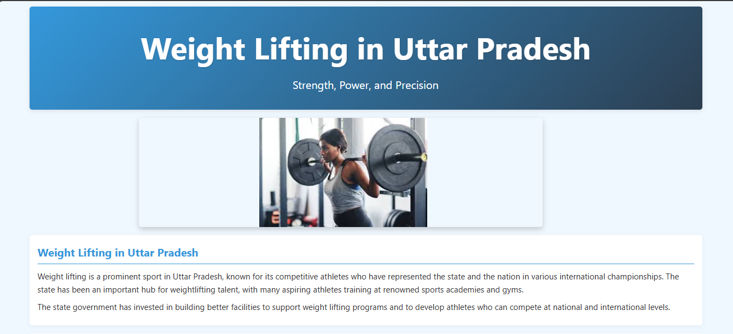

**Fig .4 :** Information of a state

In the above and below images you can see on clicking the popup the new tab is opened and you can the complete information of the particular state sport. In the new tab you can see the History, Popularity, Rules and Regulations, Benefits of the sport.

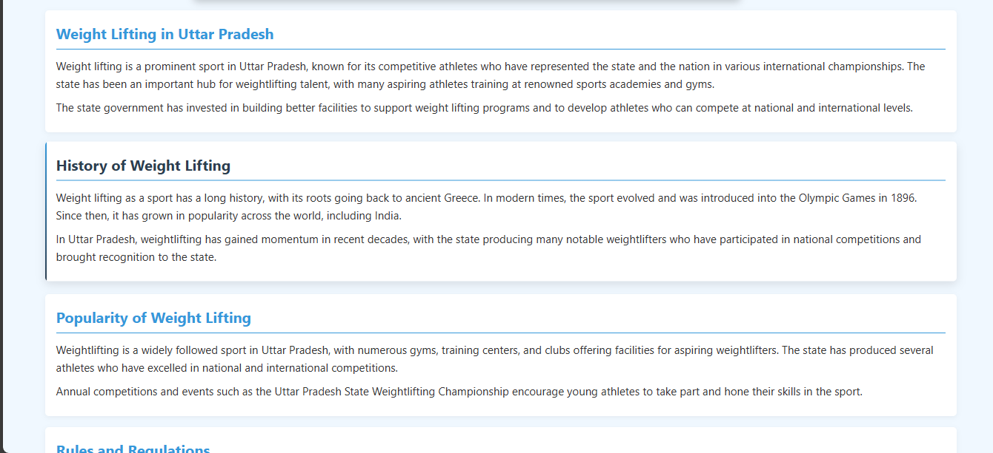

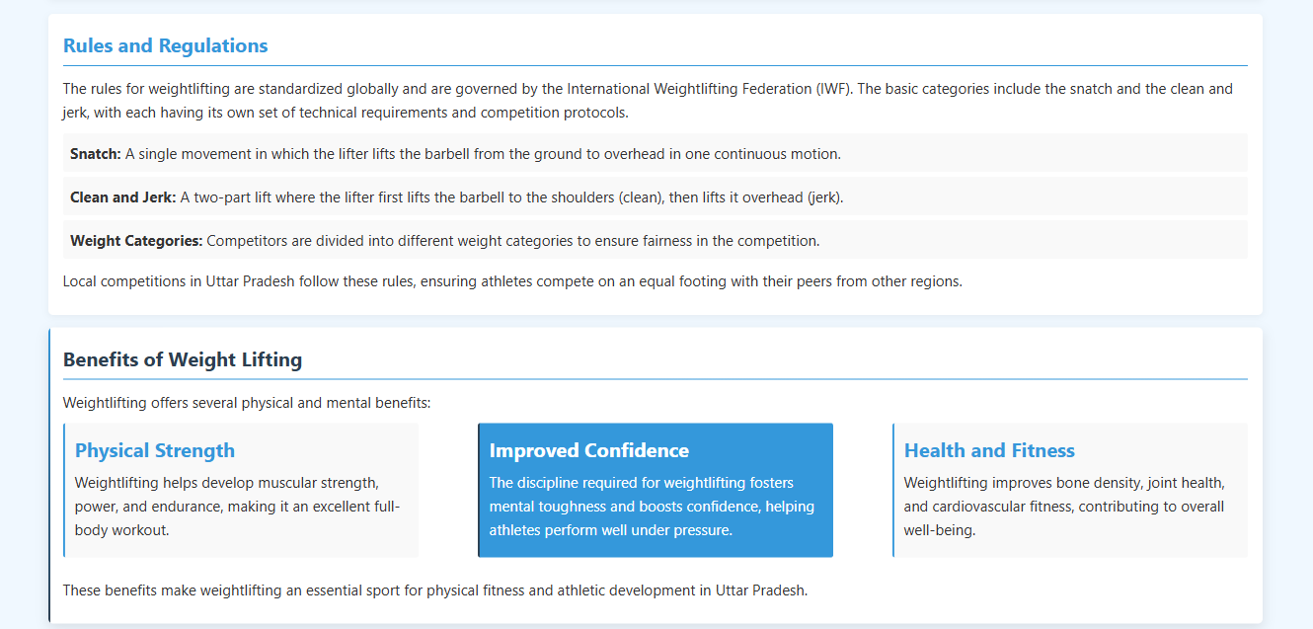

.

**VI. DISCUSSION:**

**A. Comparative Analysis with Learning Methods:**

Sports in Bharat, I've utilized a combination of technologies including HTML, CSS, and JavaScript to develop a dynamic and interactive web page showcasing a map of India. AI interactive tools have been leveraged to create a seamless user experience, enabling features like clickable states, popups, and dynamic content updates. This tech stack has allowed me to build an engaging and informative experience that provides a unique way users can explore sports across different Indian states. Each state on the map is clickable, revealing a popup that offers a concise yet informative glimpse into the sports associated with that region. The interactive design ensures every user can easily understand the specific sport linked to each state at a glance, making the experience educational, highly engaging, and interesting. By integrating these technologies, the platform serves as an intuitive and captivating resource anyone looking to learn about India's diverse sporting landscape can use.

**B. Potential Challenges and Limitations:**

While "Sports in Bharat" offers an engaging and informative experience, exploring sports across different Indian states through a dynamic map and interactive features, it has certain limitations. Currently, the platform doesn't support live updates or real-time information about ongoing sports events. Additionally, it lacks the capability to include live telecasts of sports, restricting the content to descriptive information rather than live streaming. This means users can only access pre-existing details about various sports and their significance in different regions, without the option to watch live matches or receive instantaneous updates on scores and events as they unfold.

Moreover, one of the technical challenges faced during development was ensuring seamless popup linking for each state. This involved precise mapping of state boundaries and accurate linking of popups to their respective states. Achieving this required meticulous attention to detail to avoid mismatches between state-specific information and the corresponding popups, which could lead to user confusion. Despite these challenges, the platform aims to provide a cohesive and enriching experience for users to learn about sports in India.

**VII. CONCLUSION**

We developed an interactive web application showcasing India's map, highlighting each state's official sport. Using HTML and CSS, we created a dynamic platform where users can click on a state to reveal its respective sport. This project aims to digitally showcase sports across India, promoting awareness and understanding of regional athletic traditions .While existing platforms like Bharat Maps have explored similar concepts, they have only achieved about 30% of the potential. Our project strives to take this further, covered 80% of the scope, providing a more comprehensive and engaging experience for users to explore India's diverse sporting landscape.

**VIII References:**

[7] Image-map.net